21st Century Technology for High School Teachers
Eamonn Kelly
July 13, 2014
Advisor- Ms. Booker

Setting/Context
Moody High School is one of six schools in St. Clair County and is located in east central Alabama. Moody High School is an average to slightly above average high school in the state. The Student population consists of roughly 625 students and has a staff of about 42 teachers and support staff. Demographics at Moody High School consists of 87% Caucasian, 9% African American, 3% Hispanic, .6% Asian. The Faculty Demographics is 99% Caucasian and .02% Hispanic.
Moody High School in Moody, Alabama will be taking part in 21st century technology for High School Teachers, during the fall semester of the 2014 school year. This program will take place from August to December at the High School. Participants and stakeholders will consist of the school staff and administration that attend the high schools weekly Professional Development (PD) meetings. At Moody High School each Wednesday all teachers and administrators are required to attend PD. Teachers who miss will have additional resources to view via the school Insights page. This PD will take place twice a month during the scheduled meeting time.
Problem/Rationale
Moody High School, under new administration, has seen great strides and continues to pursue the best opportunities for its students to become successful in college and in the workplace. Moody High School realizes that in this ever changing society our students will need to become more proficient with 21st century technology skills, and this can only be achieved through the enrichment of teacher skills first. Our administration has made it clear that technology in the classroom is a need and that it is a strategic focus for the school and system. Part of the system’s vision statement is to provide classroom instruction which is relevant to the 21st learner. Recently our school has showed its commitment to technology by purchasing 345 laptops for students and teachers as well as carts to store them. Professional Development time has been instituted in the high school to focus on areas of need at Moody High School.
Professional development has become a critical need at Moody High School to support the influx of new technologies into the school and is a positive impact on student achievement. Addressing the training needs in order to support teachers in utilizing technology in the classroom has become a goal of the school and system. This type of training gives the teachers the ability to use technology applications to teach in the classroom as well as the ability to provide technology support to teachers who need assistance. As a volunteer technology coach at Moody, teachers will be able to use this department as a place to turn for questions, answers, and instruction.
Technology in the classroom is nothing new in schools, just particularly at Moody High School. There has been plenty of research done to state its importance in today’s schools. Michael Simpkins and Randy Schultz in their article Using Web 2.0 Tools At School state that “Engagement is what it is all about today in education, and technology promises unique ways to engage students in learning” (2010) and Moody High School lacks these tools to reach the highest student engagement and achievement possible. Others in the education world have simply stated that technology in education is a must. Adding technology to the classroom makes the regular classroom much more intriguing and fun. The National council for accreditation of Teacher Education (NCATE) states that in a teacher education program, “The Units commitment to the integration of technology to enhance candidate and student learning” is required (Kemp, 2014). Kemp and his colleagues also state that because of this standard from NCATE, the integration of technology is a critical and required part of any teacher education program. Teachers around the country feel that using technology enhances the teaching practice and promotes multiple literacies and establishes a community of effective discussion goers (Kemp, 2014). Technology enables both students and teachers to easily utilize multiple types of resources online, as well as software that increase the varieties of input and output methods (Kemp, 2014). These are great reasons to why Professional development is needed at Moody High School. Teachers at Moody High School lack the skills to help students with the technology tools to become successful in this 21st century marketplace.
Objectives/Deliverable
Objectives
- Provide two professional development sessions per month for five months during the fall semester of the 2014 school year.
- Teachers will have the ability to share information with one another through the school wiki and eventually share lessons that were a success
- Through the site technical support will be given to teachers at the High School.
- Provide deliverables to teachers who miss Professional Development over the school Wiki or insights page.
Deliverables
- All Teachers will be given hardcopy handouts of presentations and access to online downloadable content through teacher Wiki or Insights page.
- Creation of Presentations for professional development sessions

PSC Standards

Visionary leadership
Technology Coaches inspire and participate in the development and implementation of a shared vision for the comprehensive integration of technology to promote excellence and support transformational change throughout the instructional environment.
  - Contribute to the development, communication, and implementation of a shared vision for the comprehensive use of technology to support a digital-age education for all students

Teaching, learning, and assessments
Technology Coaches assist teachers in using technology effectively for assessing student learning, differentiating instruction, and providing rigorous, relevant, and engaging learning experiences for all students.
  - Student learning and technology literacy by applying a rich variety of formative and summative assessments aligned with content and student technology standards
  - Coach teachers in and model effective use of technology tools and resources to systematically collect and analyze student achievement data, interpret results, and communicate findings to improve instructional practice and maximize student learning

Digital age learning environments
Technology coaches create and support effective digital age learning environments to maximize the learning of all students.
  - Maintain and manage a variety of digital tools and resources for teacher and student use in technology-rich learning environments
  - Troubleshoot basic software, hardware, and connectivity problems common in digital learning environments
  - Collaborate with teachers and administrators to select and evaluate digital tools and resources that enhance teaching and learning and are compatible with the school technology infrastructure.
  - Use digital communication and collaboration tools to communicate locally and globally with students, parents, peers, and the larger community.

Professional development and program evaluation
Technology coaches conduct needs assessments, develop technology-related professional learning programs, and evaluate the impact on instructional practice and student learning.
  - Conduct needs assessments to inform the content and delivery of technology-related professional learning programs that result in a positive impact on student learning
  - Design, develop, and implement technology-rich professional learning programs that model principles of adult learning and promote digital age best practices in teaching, learning, and assessment
  - Evaluate results of professional learning programs to determine the effectiveness on deepening teacher content knowledge, improving teacher pedagogical skills and/or increasing student learning

Content knowledge and professional growth
Technology coaches demonstrate professional knowledge, skills, and dispositions in content, pedagogical, and technological areas as well as adult learning and leadership and are continuously deepening their knowledge and expertise.
  - Engage in continual learning to deepen content and pedagogical knowledge in technology integration and current and emerging technologies necessary to effectively implement the Standards.
  - Engage in continuous learning to deepen professional knowledge, skills, and dispositions in organizational change and leadership, project management, and adult learning to improve professional practice
  - Regularly evaluate and reflect on their professional practice and dispositions to improve and strengthen their ability to effectively model.
Project Description
Technology for High School Teachers will begin at the end of July with the creation of surveys and deliverables for professional development at Moody High School. Teachers will receive an interest survey during our pre-planning meetings at the beginning of August. These surveys will gauge teacher’s interest in certain 21st century technologies, as well as figuring out how much technology is used on a daily basis. This survey, as well as the post survey, will be given over Google Docs. All teachers will receive the link to the survey on paper and through email. After the surveys have been completed and analyzed, professional development sessions will be developed. All professional development sessions will be created to meet the certain needs Moody’s teachers. The school Wiki will be used to place information for teachers who missed professional development, or for use to comment about information from PD. There will be two PD sessions per month for the teachers. During these sessions teachers will be hands on with the technology that they are learning. The PD sessions will consist of the partners, to help keep the bandwidth low. All PD sessions will last for 30-45 minutes, or until the administration shuts it down. All teachers involved will have an assignment attached to the PD so that they can get some time logged using it. Some of the 21st century tools that will be discussed are Audacity, Jing, Screencast.com, and various tools that can be used in the classroom. Teachers will be expected to integrate the technology tools within their curriculum. Lesson plans will support this integration and will be uploaded to the school network where they can be reviewed by the administration and other teachers.
Timeline for Professional Development
Late July | Begin creating presentations for professional development.
August | Continue presentation creation for professional development.
Late August | Start first presentation for Moody High School Faculty.
September | 2 professional development sessions with Moody Faculty (Wed morning 7:30-8:50)
October | 2 professional development sessions with Moody Faculty (Wed morning 7:30-8:50)
November | 2 professional development sessions with Moody Faculty (Wed morning 7;30-8:50)
December | 1 professional development sessions with Moody Faculty (Wed morning 7:30-8:50)
Late December | Survey for Faculty on the helpfulness of the 21st century professional development sessions.

Each month teachers will be asked to share lessons that involved 21st century technology in the classroom. This information will be shared on the school Wiki so others can share in the achievements of Moody’s Teachers. All Teacher lesson plans will be submitted on the school network for other teachers to view and use.
Resources
- School Provided Laptops
- Access to the School WIFI
- Google Docs
- Access to school Wiki
- Access to download tools that have been taught during Professional Development
Evaluation
To evaluate teachers at Moody High School, teachers will take a survey (Appendix B) upon completion of the professional development sessions to gauge their effectiveness. Effectiveness will be measured by use in classroom lessons, which will be shown through lesson plans and sharing of success lessons. Lesson Plans will be submitted to school administration for adequate feedback in the evaluation process. Also used in the evaluation process will be teacher evaluations that Moody gives at the end of the year, which a technology question will be placed. This will serve as feedback for teachers who have bought into 21st century technology for High School Teachers.

References
Kemp, A.T, Preston, J., Page, C., Harper, R., Dillard, B., Flynn, J., & Misato, Y.
(2014). Technology and teaching: A conversation among faculty regarding the pros and
cons of technology. Qualitative Report, 19(3), 1-23
Simpkins, M. (2010). Using web 2.0 tools at school. Leadership, 39(3), 12-38.

Appendix A
Interest Survey
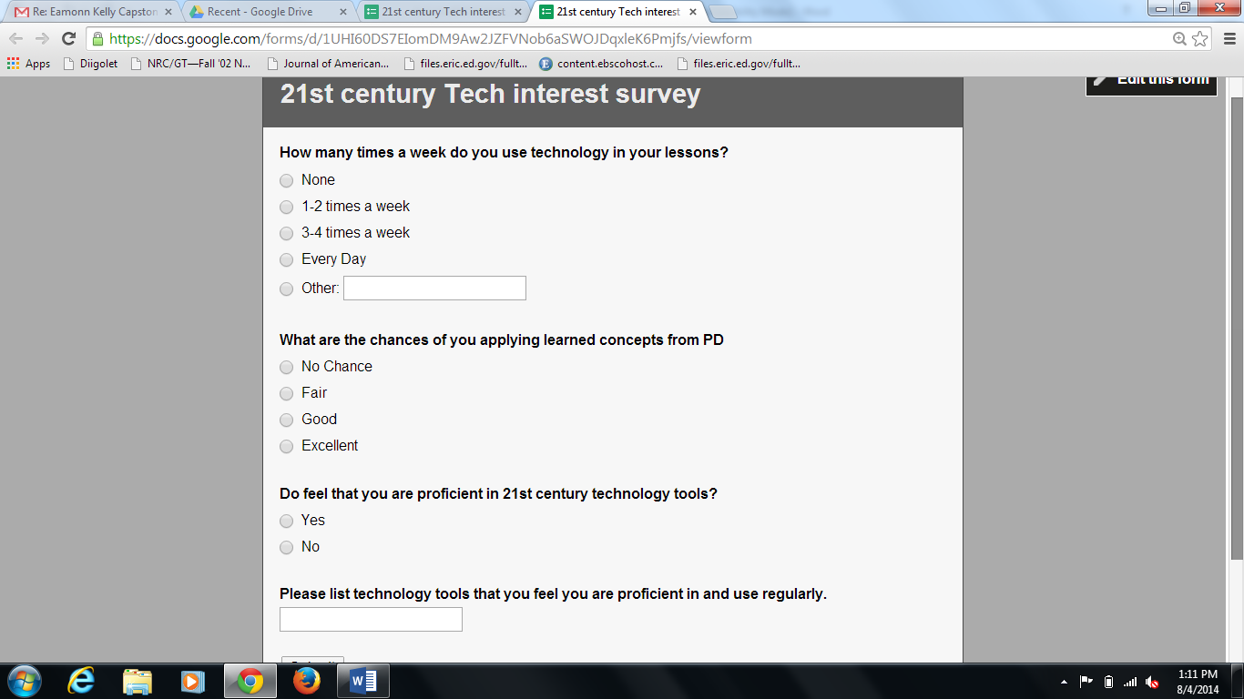

Questions on the Survey consist of
- How many times a week do you use technology in your lessons?
- What are the chances of you applying learned concepts from PD?
- Do you feel you are proficient in 21st century technology tools?
- Please list technology tools that you feel you are proficient in and use regularly?

Appendix B
Post Survey
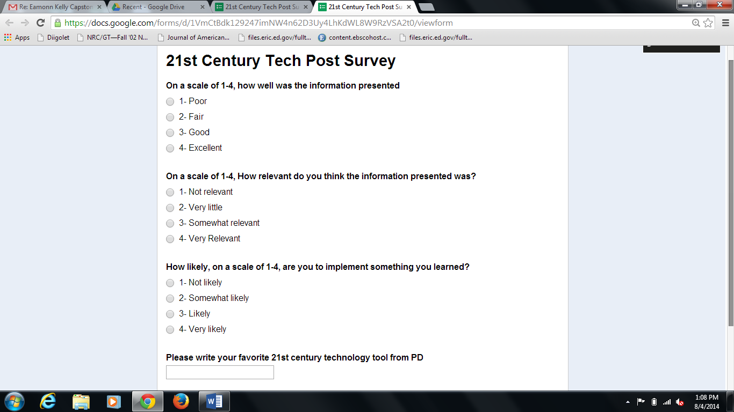

Questions on the survey
- On a scale of 1-4, how well was the information presented?
- On a scale of 1-4. How relevant do you think the information presented was?
- How likely, on a scale of 1-4, are you to implement something you learned?
- Please write in your favorite 21st century technology tools from PD?

